SOFTWARE DESIGN DOCUMENT

RESTAURANT MANAGEMENT APPLICATION

TEAM: Summer Interns - 2015

Akshay Jarandikar

Megha Mukim

Milind Gokhale

Shrijit Vijayan Pillai

Shruthi Katapally

Vimalendu Shekhar

**Purpose:** This software design document describes the architecture and system design of the app E-Ordering in a Restaurant.

**Architectural Design:**

We have some Visual Force pages and Apex classes which control the flow of the application.

They are:

* Tables pages, where the manager will have the list of table details with seats available and status. The guests will be allocated appropriate table. When the table is selected, the status is changed to Occupied.
* Menu page displays the menu items. On the upper side, special offers are displayed. Menus are divided into 3 sections namely appetizers, entrée and dessert. In each section, user can select vegetarian, non-vegetarian and vegan items. By clicking on the item, customer can view the food details. By pressing Add button, the item will be added in the cart. The cart is displayed on right side. The items in the cart can be modified before the place order button is clicked. Customer can see the total amount to be paid along with the taxes. When the item is delivered, waiter will mark item as delivered.
* Bill page gets enabled when all the items in the order are delivered. This page will display the name, quantity and amount for each item. The total will be displayed below it. Bill Page also has option to provide tip. This will change the total amount. By clicking on done button, the order is completed and order will be closed. At the end of the page, customer can give feedback.
* **Chef_Pending_Orders:** This page displays the list of ordered item by customers. Chef will click Accept button when he starts cooking the order item. After this moment, customer cannot modify the item count that chef has started preparing. When the item is ready, chef will click on Ready button. This will notify the waiter screen that item is prepared. Now waiter will serve the particular item.
* **WaiterOrderPage:**This page displays the list of food items which are ready to deliver. Waiter will pick the items and deliver to the table number specified with the item. He will click on Pickup button when he takes the item.

Following is a flow chart of the status of the Food Order and Order Items

**FOOD ORDER STATUS**

When order accepted

When all the item’s status have changed to picked up

When customer clicks pay now

**ORDER ITEM STATUS**

When place order button is clicked

When chef clicks accept button

When chef clicks ready button

When waiter presses the pickup button

When waiter/customer clicks delivered button

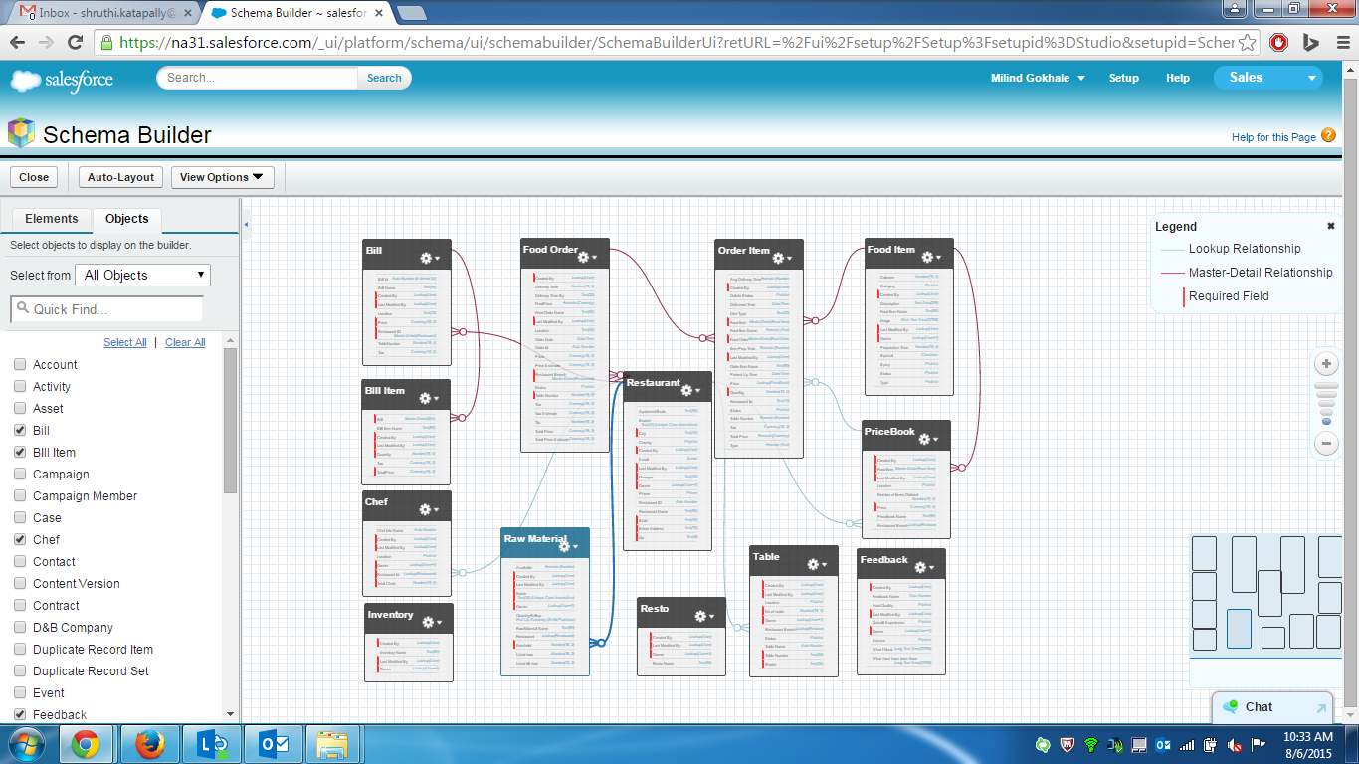Schema diagram